**Note:**  
  
Data contained in these findings may be sensitive or confidential. It is intended for viewing only by those involved in the investigation, prosecution, defense, and adjudication of this case. Any other viewing is not authorized.  
  
**Executive Summary**  
  
Special Agent Frank WILSON #345 of the Ministry of Wacky Walks, Bureau of Criminal Investigations, requested an examination of evidence for any information regarding the tax investigation in the Al CAPONE case. Special Agent Frank WILSON #345 of the Ministry of Wacky Walks, Bureau of Criminal Investigations, requested an examination of evidence for any information regarding the tax investigation in the Al CAPONE case. On 1931-01-05 Digital Forensic Examiner (DFE) HOLMES attended the warrant at 7244 Prairie Avenue, Chicago Illinois. DFE HOLMES read a copy of the search warrant authorizing the digital forensic analysis of digital computers, DVR’s, phones, cars and media.  
  
**Search Warrant Operation   
  
On Scene Triage**   
  
On 1931-01-05, at around 0940 hrs, law enforcement personnel contacted DFE HOLMES stating the location was secured and they were ready for forensic assistance. The entry log was signed upon entry.   
  
A computer was on and running at the front room area of the home. The date and time displayed on the monitor was consistent with the current date and time. DFE HOLMES entered a small office behind the front room. A Night Owl Digital Video Recording (DVR) system appeared on, but the display monitor was not showing any of the camera activity. Later, this DVR was labeled as evidence Item 9. A successful attempt to log into the DVR system with a username of “dvr” and a password of “dvr”, provided by Special Investigator Frank WILSON. The date and time of the DVR system was unable to be verified.   
  
At around 1349 hrs, a forensic storage drive was plugged into a Compaq computer located under the table at the West end of the table. This computer was labeled as evidence Item 15. Belkasoft RAM Capture (no version information available) forensic software was used to copy the random access memory (RAM) of the computer. At around 1403 hrs, the collection finished and the forensic storage drive was removed.   
  
An LGE LM-V600 phone was located in the office. The date and time displayed on the phone was consistent with the current date and time. At around 1420 hrs, the phone was put into airplane mode. This phone was labeled as evidence Item 13.   
  
Magnet Forensics Encrypted Disk Detector (version 3.1.0) forensic software was used to check Item 15 for encryption. The search results did not detect any encryption software. The power cable was removed from the back of the computer to disconnect it from the power source and prepare it for evidence collection.   
  
Property Inventory and Chain of Custody forms were completed for the seized items. DFE HOLMES transported the seized items to the Chicago Investigations Division Evidence Room, located at 569 North Fifth Street, Chicago, IL. The items were placed into Evidence Intake for secure storage.  
  
  
**Forensic Imaging  
  
Exhibit 9**  
  
A Night Owl DVR-THD80B-82-HIK DVR (S/N: 858A216153238) was received on 1931-08-02. DFE HOLMES used Tableau Imager 20.3.0, utilizing a Tableau T356789iu write blocker, to conduct a disk to file manual analysis on the Kingston 2383 (S/N: 1234567889.0) 6 TB SATA drive. The image was processed with Magnet Witness. "dvr" with a password of "dvr" was a login to this DVR.  
  
The videos range from 1931-05-22 at 02:03 to 1931-07-28 at 01:00. There were 4 active cameras being used out of 8 available video inputs. Audio was not recorded by this DVR. Channel 1 shows the kitchen. Channel 2 is behind the bar. Channel 3 is in the kitchen sink area. Channel 4 is over the front table. Channel 5, 6, 7 and 8 have no signal. Screenshots of each camera view were taken, see Figures 1 - 4. Additional DVR analysis is available upon request. A video of sample clips, 1931-172_Ex*9.mp4, was created with OpenShot v3.3.0. The exported video includes a clip of Al CAPONE handing a Chicago Police Department officer an envelope on 1931-05-13 at 13:03:23 (See Figure 2). The video further shows the officer pull out a stack of 100 dollar bills and proceed to count them at the bar. (EXAMINERS NOTE: Al CAPONE was identified by Frank WILSON #345 based on analysis of his drivers license and personal interactions during previous interviews by WILSON. END NOTE)

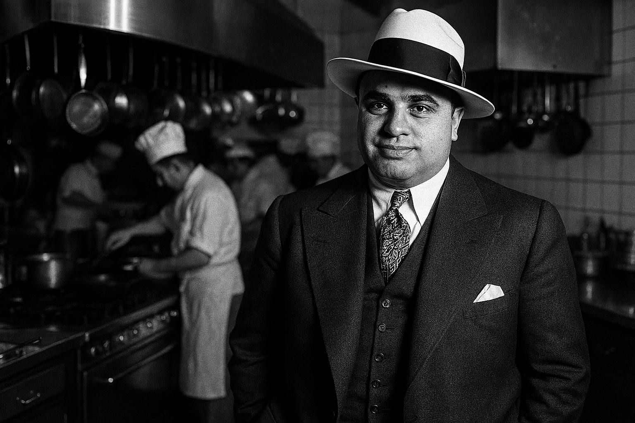

Figure 1: - Camera 1 - Kitchen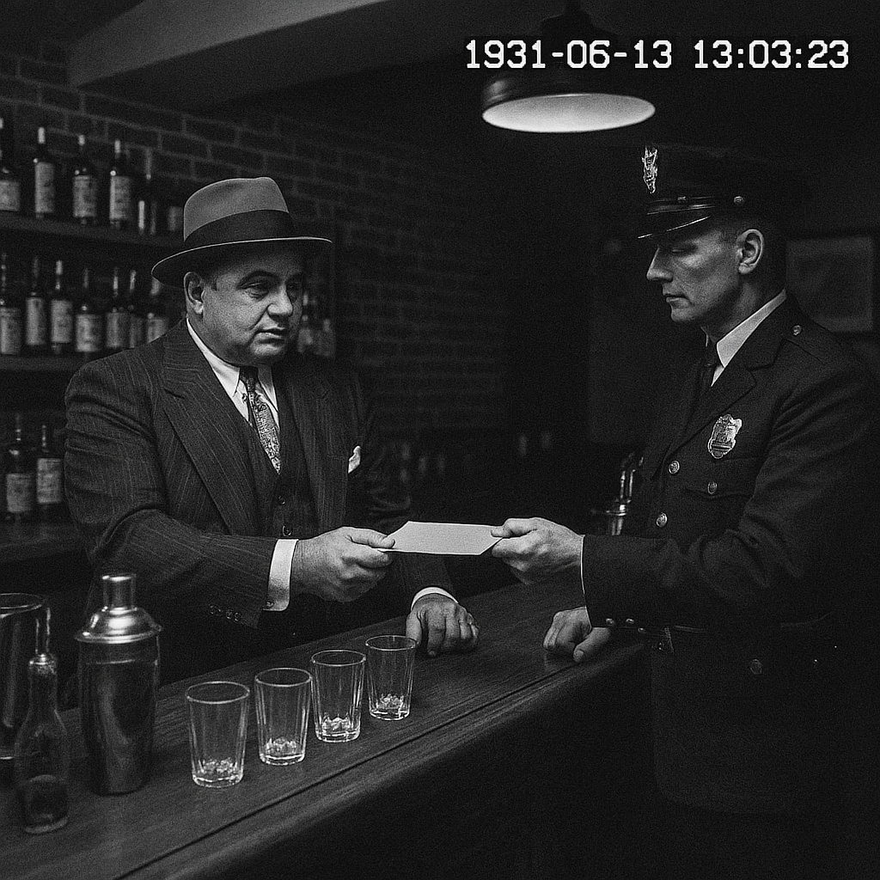

Figure 2: - Camera 2 – handing the officer an envelope at the bar

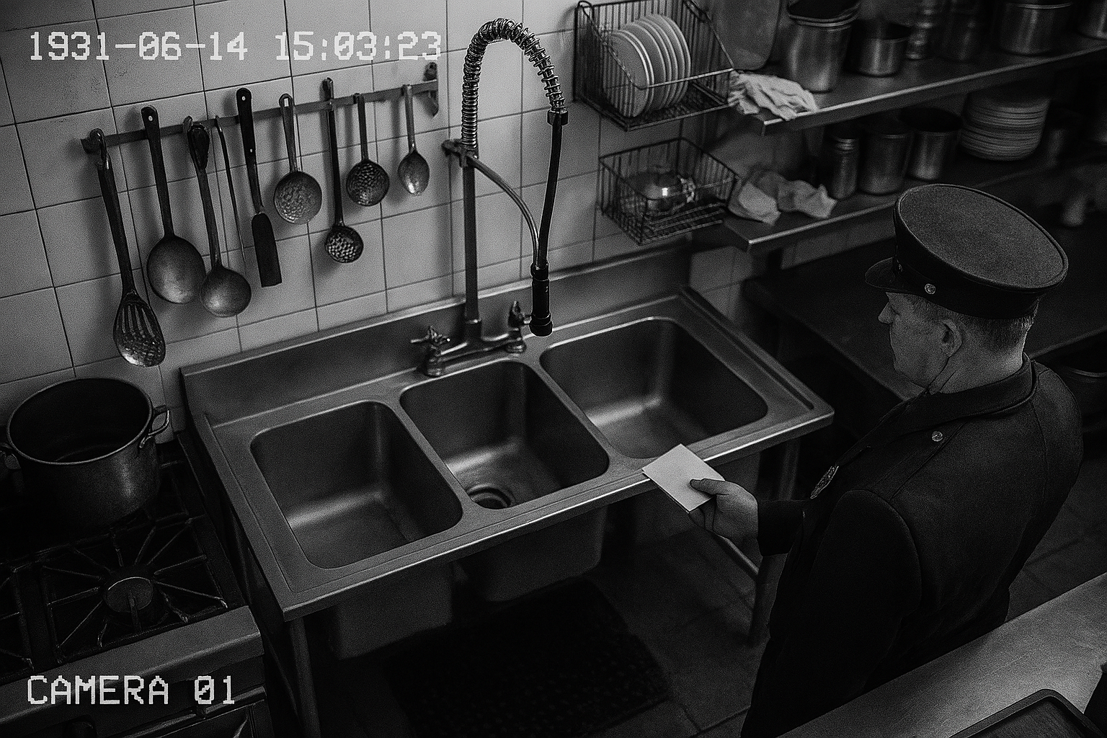  
Figure 3 - Camera 3 – Kitchen sink  
  
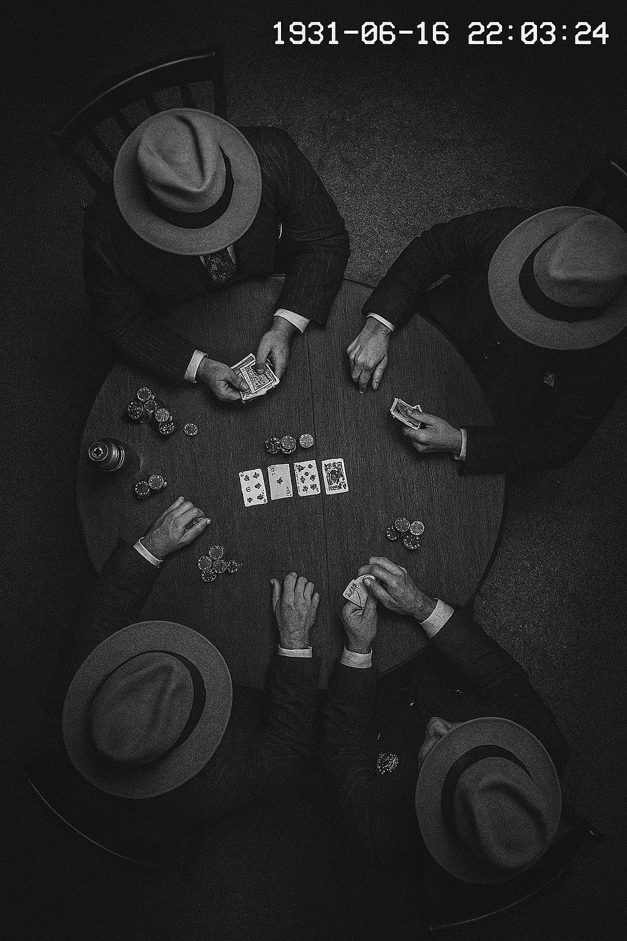  
Figure 4: - Camera 4 – Men playing cards

**Exhibit 12**  
  
A 1931 Buick Encore (Carrier: AT&T) vehicle (IMEI: 861536030696002) (S/N: 1RBCJASB1ABE05631) (OS: OnStar Gen10) was received on 1931-08-02. DFE HOLMES used Berla iVe 3.5.0.29841 to conduct forensic extraction. The image was processed with Cellebrite Physical Analyzer 8.1.0.7.  
  
The registration located in the glove box of this car had ‘Al COPONE’ listed as the registered owner. Apple Car play was synced to to sync up with 13125551212. Relevant files were exported. This vehicle was returned to the owner on 1931-10-02.

**Exhibit 13**

A LGE LM-V600 Verizon phone (MSISDN: 13125551212) (IMEI: 3525712230469390) (MSISDN2: 13125556912) (IMEI2: 3525716930469390) (S/N: DNPVABEZJCL9) (OS: Android 11) was received on 1931-08-02. On 08/02/1931 at 14:06:48 (-5), DFE HOLMES used Cellebrite UFED 7.56.0.282 to conduct an advanced logical phone extraction.  
The image (MD5 Hash: ad0234829205b9033196ba818f7a872b) was saved as EvidenceCollection.ufdx. The forensic imaging process was completed successfully and verified with no errors. The source hash was calculated and confirmed unchanged before processing. The acquisition and verification hash values matched, ensuring data integrity.  
  
 Source MD5 hash: ad0234829205b9033196ba818f7a872b  
 Verification MD5 hash: ad0234829205b9033196ba818f7a872b  
  
The image was processed with Cellebrite Physical Analyzer 8.1.0.7 and further analyzed with mac_apt.exe. The forensic image hash value was verified prior to processing thereby confirming the data remained unaltered prior to processing. "AlCOPONE@gmail.com" with a password of "Password1234" was an email configured on this phone.  
  
Al CAPONE gave Frank WILSON "193104" as the pincode to the phone. "AlCAPONE@gmail.com" with a password of "193104" was an email configured on this phone. This phone contained 176 MMS (multimedia messaging service) messages between AlCAPONE@gmail.com and 16185551211 (Alex) discussing having two ledgers (See Figure 5). One thread from the phone discusses There were message between AlCOPONE@gmail.com and accountant1492@gmail.com. Relevant files were exported. This phone was returned to the owner on 1931-10-02.

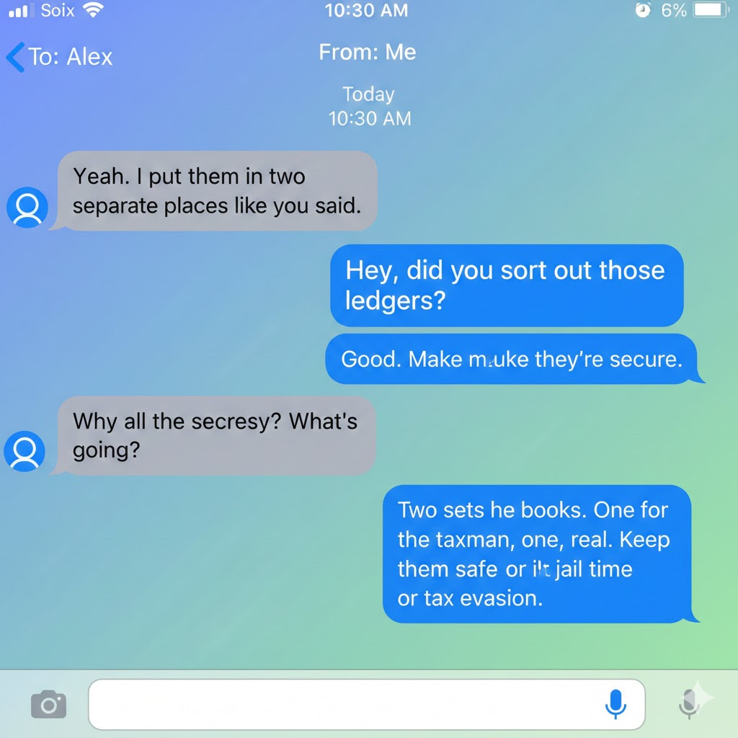

Figure 5 – Ledgers message

According to the Cellebrite Preliminary Device Report (Preliminary_Device_Report.pdf), the “Find My” account is registered under the name Al CAPONE, with the associated Apple ID listed as AlCOPONE@gmail.com.  
  
A variety of Cellebrite logs were exported:   
 Accounts_Al_Capone_Ex_13.xlsx  
 Calls_1931-172_Al_CaponeEx13.xlsx  
 Chats_1931-172_Al_CaponeEx13.xlsx  
 Contacts_1931-172_Al_CaponeEx13.xlsx  
 Emails_1931-172_Al_CaponeEx13.xlsx  
 Financial_Transfers_1931-172_Al_CaponeEx13.xlsx  
 Journeys_1931-172_Al_CaponeEx13.xlsx  
 Locations_1931-172_Al_CaponeEx13.xlsx  
 Notes_1931-172_Al_CaponeEx13.xlsx  
 Passwords_1931-172_Al_CaponeEx13.xlsx  
 SearchedItems_1931-172_Al_CaponeEx13.xlsx  
 Voicemails_1931-172_Al_CaponeEx13.xlsx  
 WebHistory_1931-172_Al_Capone_Ex_13.xlsx  
The image was triaged using ILEAPP 2.3.0. Relevant artifacts and parsed data were extracted and compiled into a spreadsheet titled ILEAPP_Ex_13.xlsx for evidentiary review.  
  
A consolidated intelligence spreadsheet containing call logs, contacts, account details, notes, search history, GPS coordinates, chat records, and web activity was saved as _Intel_1931-172_Al_Capone_.xlsx_ for investigative reference.  
  
A total of 554 call logs were identified. The associated WhatsApp Push Name is listed as Al CAPONE.  
  
GPS data was exported as Locations_1931-172_Al_CaponeEx13.xlsx.   
(Examiner’s Note: The coordinates were geocoded by DFE HOLMES into physical addresses and, where available, associated business names. This enriched dataset was saved as locations2addresses1931-172_Al_Capone_13.xlsx. To support geospatial visualization, a KML file titled gps1931-172_Al_Capone.kml was generated for use in [Google Earth](https://earth.google.com/). A filtered version, gps_Illinois.kml, was also created by DFE HOLMES to isolate locations within the state of Illinois. End Note.)  
  
The GPS coordinates 41.7624916,-87.6213316 (7244 Prairie Avenue, Chicago Illinois) were identified by CASTViz as a hotspot, indicating a high density of GPS activity. Figure 6 illustrates this location as a concentrated cluster of detections, consistent with sustained device presence or usage in the area.   
(Examiner’s Note: According to Family Tree Now (https://www.familytreenow.com/search/people/results?first=Al&last=Capone&citystatezip=Chicago,%20IL&rid=asa&smck=J25nUBu_7zMhesds44TNVg), Al CAPONE is listed as a resident at this address. See Figure 7. END NOTE)  
  
The Cellebrite Reader report was exported under the filename Prelimnary_Report_1931-172_Ex_13.ufdr. A malware scan was conducted using Cellebrite, and the results were incorporated into the UFDR report. No malware was detected.  
  
A set of tagged photographs was saved under the filename Photos_Ex_13.pdf. The file contains visual documentation including bulk quantities of cigarettes loaded in vans, annotated map screenshots, handwritten notes, calculator display captures, and various other cigarette-related images.  
  
Chats were exported as Chats_Ex_13.pdf.

**Exhibit 14**  
  
An eckotec (blue) USB storage drive (S/N: 1234) was received on 1931-08-02. DFE HOLMES conducted a manual analysis.  
  
Digital Forensics Examiner (DFE) HOLMES conducted a manual analysis of the device. The USB drive was found to be empty; a comprehensive search for relevant files yielded no results. The device was returned to its owner on 1931-10-02.

**Exhibit 15**  
  
A Compaq Presario II server (S/N: ABESL65848Z411234) (OS: Window 10) (Hostname: notCompaq) was received on 1931-08-02. On 08/03/31 at 08:49 AM, DFE HOLMES used Tableau Imager 20.3.0, utilizing a Tableau T356789iu write blocker, to conduct a disk to file forensic extraction on the Kingston 2383 (S/N: 1234567889.0) 123 GB SATA drive. A write blocker is a tool that prevents any write access to a device, thus only allowing for read-only access to maintain the integrity of the evidence. The image (MD5 Hash: 6f1ed002ab5595859014ebf0951522d9) was saved as Ex10.e01. The imaging process completed with no errors and was verified. The acquisition and verification hash values matched and are listed below:  
  
 Source MD5 hash: 6f1ed002ab5595859014ebf0951522d9  
 Verification MD5 hash: 6f1ed002ab5595859014ebf0951522d9  
  
The image was processed with FTK 7.5.1.127 and further analyzed with Arsenal Image Mounter 3.9.223, memdump, magnet encrypted disk detection and Kape. "administrator" with a password of "password1234" was a login to this server. "AlCOPONE@gmail.com" with a password of "Password1234" was an email configured on this server.  
  
Quicken and Turbo Tax were both installed on this server. Relevant files were exported. This server was returned to the owner on 1931-10-02.

Web history logs were exported as WebHistory_1931-172_Al_CAPONE_EX_15.xlsx, using Kape.

**Report Conclusion**  
  
This document contains findings regarding the analysis of digital evidence that was submitted for forensic examination. The data contained in these findings and data extractions should not be regarded as evidence, but rather findings concerning that evidence. Contact the case officer or prosecutor to obtain the evidentiary data.  
  
It should be noted that not all files were reviewed during this examination. It is incumbent upon the requester to thoroughly review the data and make a determination as to the probative or exculpatory nature of any and all information.  
  
All forensic equipment and software is functionally tested/validated without errors. Where possible, before utilizing stand-alone write blockers, firmware was updated to the current version and functionality was verified.  
  
All forensic acquisition, analysis and write-blocking software used for this case is licensed and/or registered to DFE HOLMES and/or the Ministry of Wacky Walks.  
  
This report contains digital examination of the exhibits provided based on the investigative information and tools available to the examiner at the time of the analysis.   
  
A copy of this report will be given to Frank WILSON #345. Additional analysis may be requested after review of the report or as the investigation continues.  
  
All digital images obtained pursuant to this investigation will be maintained on IDOR servers for five years past the date of adjudication and/or case discontinuance. Copies of digital images will be made available upon request. All files copied from the images and provided to the case agent for review are identified as the DIGITAL EVIDENCE FILE and will be included as an exhibit in the case file.